Solution:-

1).

Code

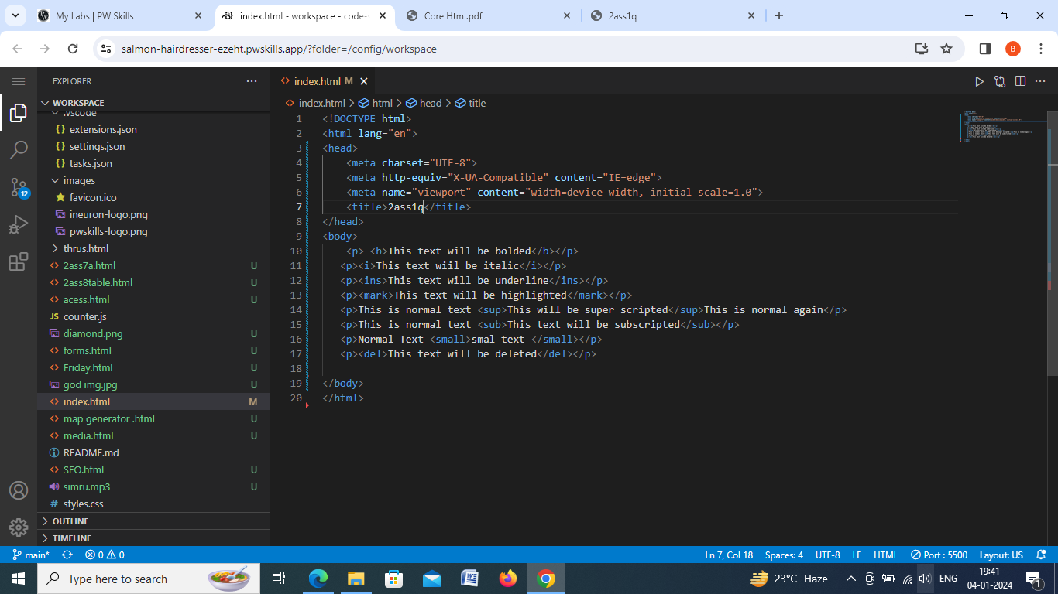

1.output-

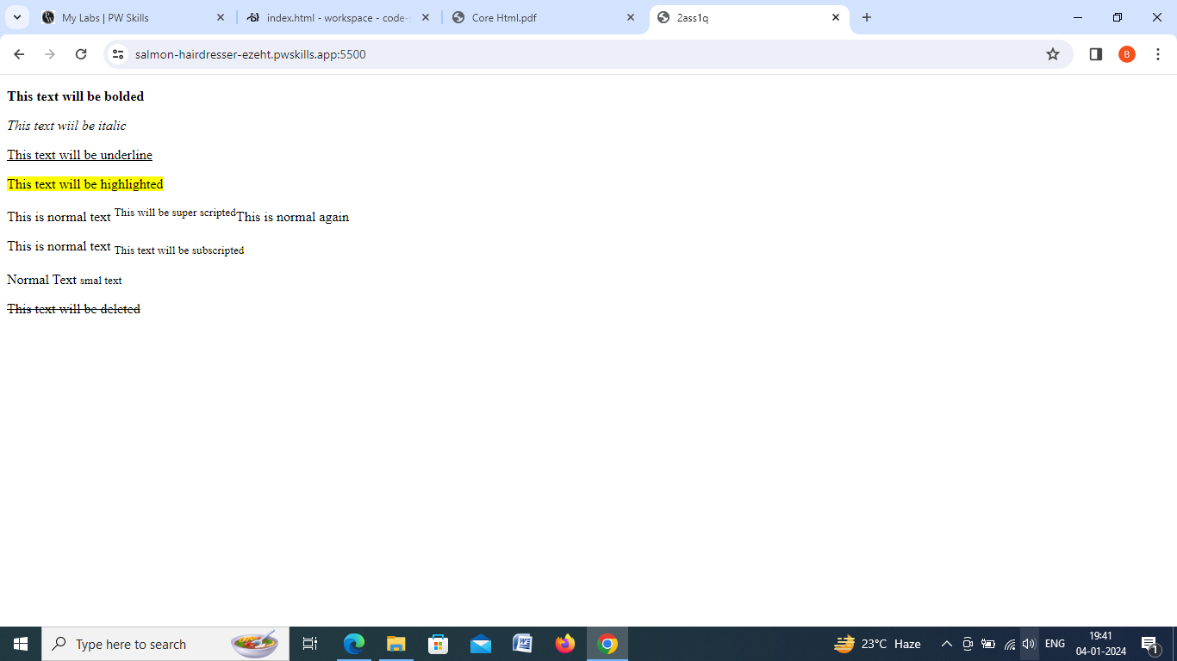

2.)

Code-

<!DOCTYPE html>

<html lang="en">

<head>

    <meta charset="UTF-8">

    <meta http-equiv="X-UA-Compatible" content="IE=edge">

    <meta name="viewport" content="width=device-width, initial-scale=1.0">

    <title>2ass2q</title>

</head>

<body>

    <p>Take me to <a href="https://learn.pwskills.com/lesson/02Sept%2223-Getting-Started-with-HTML/64f33513fe327f8ccca348ac/course/Full-Stack-Web-Development/64a514966977cc6e87e27504#">PW Skills</a>To buy a course</p>

<p>Take me to <a href="https://developer.mozilla.org/"> MDN docs</a> to know more about the web Devlopment </p>

<p>Take me to<a href="https://lab.pwskills.com/my-labs">PW Skills lab </a>to practice live coding</p>

</body>

</html>

Output-

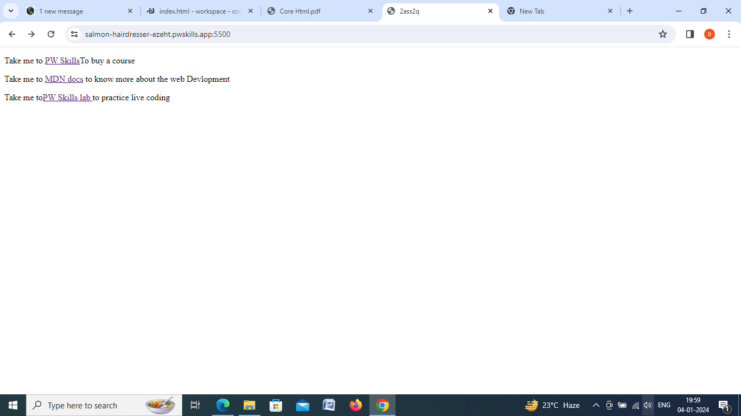

3.1)

Code-

<!DOCTYPE html>

<html lang="en">

<head>

<meta charset="UTF-8">

<meta http-equiv="X-UA-Compatible" content="IE=edge">

<meta name="viewport" content="width=device-width, initial-scale=1.0">

<title>2ass3q</title>

</head>

<body>

<div>

<a href="./https://www.w3schools.com/html/html_intro.asp">Home</a> |

<a href="./https://en.wikipedia.org/wiki/Web_development#:~:text=Web%20development%20is%20the%20work,businesses%2C%20and%20social%20network%20services.">web devlopment</a> |

<a href="./https://www.simplilearn.com/what-is-web-designing-article">web design</a>

</div>

<div>

<h1>About html</h1>

<p>

HTML is an acronym which stands for Hyper Text Markup Language which is used for creating web pages and web applications. Let's see what is meant by Hypertext Markup Language, and Web page.

<br>

Hyper Text: HyperText simply means "Text within Text." A text has a link within it, is a hypertext. Whenever you click on a link which brings you to a new webpage, you have clicked on a hypertext. HyperText is a way to link two or more web pages (HTML documents) with each other. <br>

Markup language: A markup language is a computer language that is used to apply layout and formatting conventions to a text document. Markup language makes text more interactive and dynamic. It can turn text into images, tables, links, etc

</p>

</div>

</body>

</html>

3.2)

<!DOCTYPE html>

<html lang="en">

<head>

<meta charset="UTF-8">

<meta http-equiv="X-UA-Compatible" content="IE=edge">

<meta name="viewport" content="width=device-width, initial-scale=1.0">

<title>2ass3q</title>

</head>

<body>

<div>

<a href="./https://www.w3schools.com/html/html_intro.asp">Home</a> |

<a href="./https://en.wikipedia.org/wiki/Web_development#:~:text=Web%20development%20is%20the%20work,businesses%2C%20and%20social%20network%20services.">web devlopment</a> |

<a href="./https://www.simplilearn.com/what-is-web-designing-article">web design</a>

</div>

<div>

<h1>About Web development</h1>

<p>

Web development refers to the creating, building, and maintaining of websites. It includes aspects such as web design, web publishing, web programming, and database management. It is the creation of an application that works over the internet i.e. websites.

<br>

Web development is the work involved in developing a website for the Internet (World Wide Web) or an intranet (a private network).[1] Web development can range from developing a simple single static page of plain text to complex web applications, electronic businesses, and social network services. A more comprehensive list of tasks to which Web development commonly refers, may include Web engineering, Web design, Web content development, client liaison, client-side/server-side scripting, Web server and network security configuration, and e-commerce <development class="br"></development>

</p>

</div>

</body>

</html>

3.3)

<!DOCTYPE html>

<html lang="en">

<head>

<meta charset="UTF-8">

<meta http-equiv="X-UA-Compatible" content="IE=edge">

<meta name="viewport" content="width=device-width, initial-scale=1.0">

<title>2ass3.3q</title>

</head>

<body>

<div>

<a href="./https://www.w3schools.com/html/html_intro.asp">Home</a> |

<a href="./https://en.wikipedia.org/wiki/Web_development#:~:text=Web%20development%20is%20the%20work,businesses%2C%20and%20social%20network%20services.">web devlopment</a> |

<a href="./https://www.simplilearn.com/what-is-web-designing-article">web design</a>

</div>

<div>

<h1>About Web design </h1>

<p>

Web designing is the process of planning, conceptualizing, and implementing the plan for designing a website in a way that is functional and offers a good user experience. User experience is central to the web designing process. Websites have an array of elements presented in ways that make them easy to navigate. Web designing essentially involves working on every attribute of the website that people interact with, so that the website is simple and efficient, allows users to quickly find the information they need, and looks visually pleasing. All these factors, when combined, decide how well the website is designed.

<br>

Web designers create the design and layout of a website with their technical expertise and knowledge while keeping in mind the client’s requirements. They have a deep understanding of UI (user interface) and UX (user experience) and are adept at using design programs for creating visual elements. With their skills and expertise, web designers capture the brand’s identity in the design elements of the website.

</p>

</div>

</body>

</html>

**Output:**

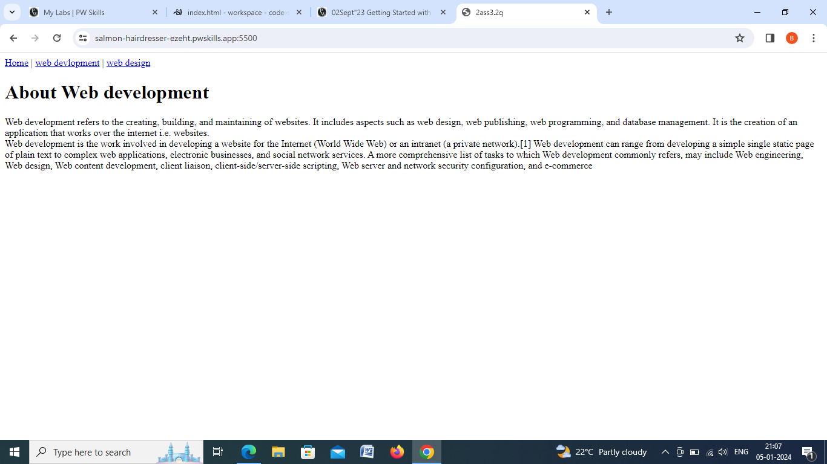

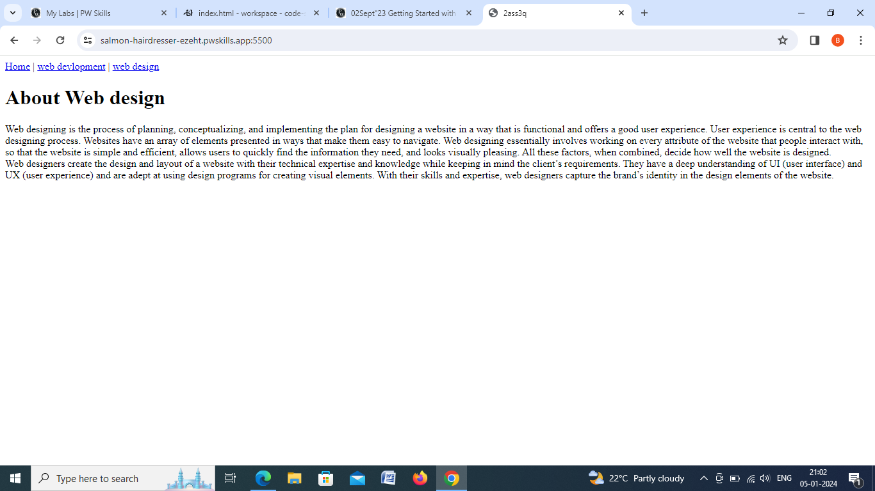

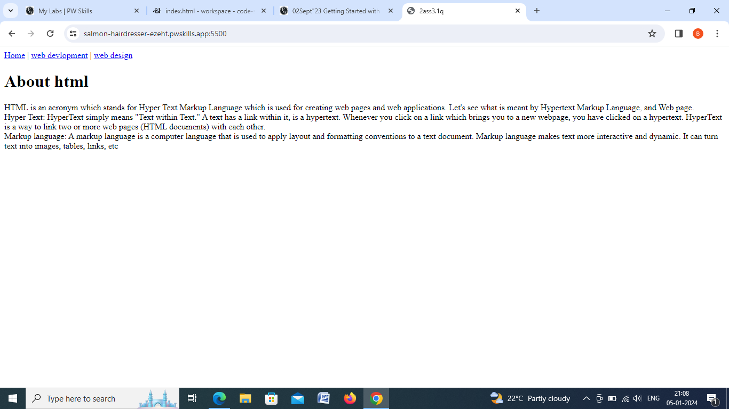

**4)**

**Code:**

<!DOCTYPE html>

<html lang="en">

<head>

    <meta charset="UTF-8">

    <meta http-equiv="X-UA-Compatible" content="IE=edge">

    <meta name="viewport" content="width=, initial-scale=1.0">

    <title>2ass4q</title>

</head>

<body>

    <ol>

        <li>ol:Defines an ordered list</li>

        <li>p:Defines a paragraph</li>

        <li>sup:Defines superscripted text</li>

        <li>Table:Defines a table</li>

        <li>td:Defines a cell in a table</li>

        <li>th:Defines a header cell in a table</li>

        <li>u:Defines some text that is unarticulated and styled differently from normal text</li>

        <li>ul:Defines an unordered list</li>

        <li>video:Defines embedded video content</li>

        <li>tbody:Groups the body content in a table</li>

        <li>svg:Defines a container for SVG graphics</li>

        <li>style:Defines style information for a document</li>

    </ol>

</body>

</html>

**Output:**

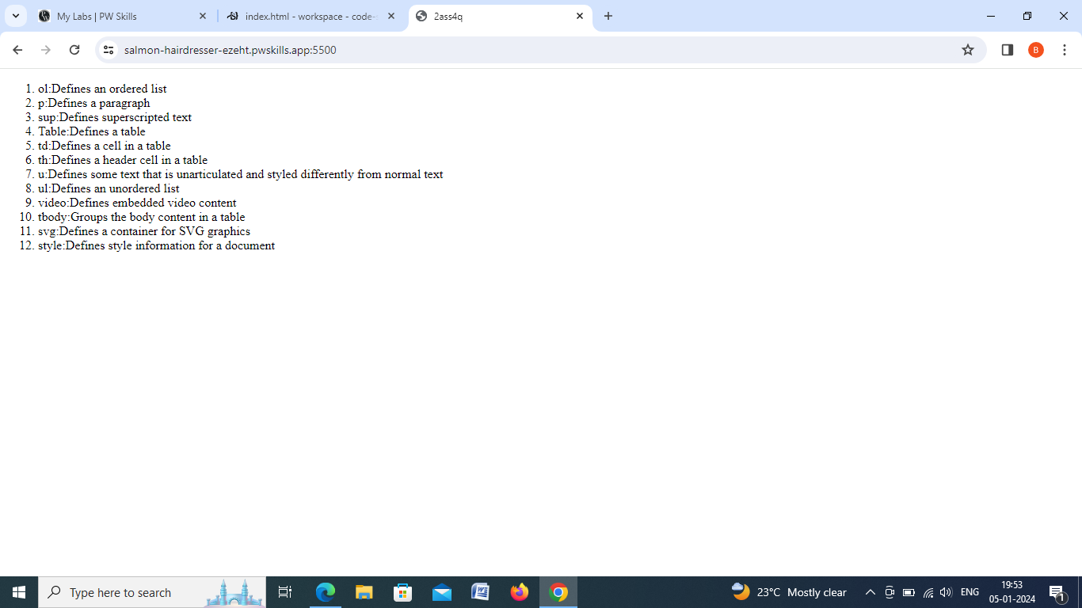

**5.)**

**Code:**

 <!DOCTYPE html>

<html lang="en">

<head>

    <meta charset="UTF-8">

    <meta http-equiv="X-UA-Compatible" content="IE=edge">

    <meta name="viewport" content="width=, initial-scale=1.0">

    <title>2ass5q</title>

</head>

<body>

    <h1>Full Stack Web Devlopment Tech Stack:</h1>

    <dl>

        <dt>HTML </dt>

        <dd>HTML stands for HyperText Markup Language. It is used to design web pages using a markup language. HTML is a combination of Hypertext and Markup language. Hypertext defines the link between web pages. </dd>

    <dt>CSS</dt>

    <dd>CSS (Cascading Style Sheets) allows you to create great-looking web pages.</dd>

    <dt>Jvascript</dt>

    <dd>JavaScript is the Programming Language for the Web. JavaScript can update and change both HTML and CSS. JavaScript can calculate, manipulate and validate data.</dd>

    <dt>Github</dt>

    <dd>GitHub is an online software development platform. It's used for storing, tracking, and collaborating on software projects.</dd>

    <dt>Talwind</dt>

    <dd>Tailwind CSS is basically a utility-first CSS framework for rapidly building custom user interfaces</dd>

    <dt>MongoDB</dt>

    <dd>MongoDB is a document database with the scalability and flexibility that you want with the querying and indexing that you need.</dd>

    <dt>DSA</dt>

    <dd> The term Data Structure refers to the storage and organization of data, and Algorithm refers to the step by step procedure to solve a problem. </dd>

    <dt>MySQL</dt>

    <dd>MySQL is a relational database management system (RDBMS) developed by Oracle that is based on structured query language (SQL).</dd>

    </dl>

</body>

</html>

**Outout:**

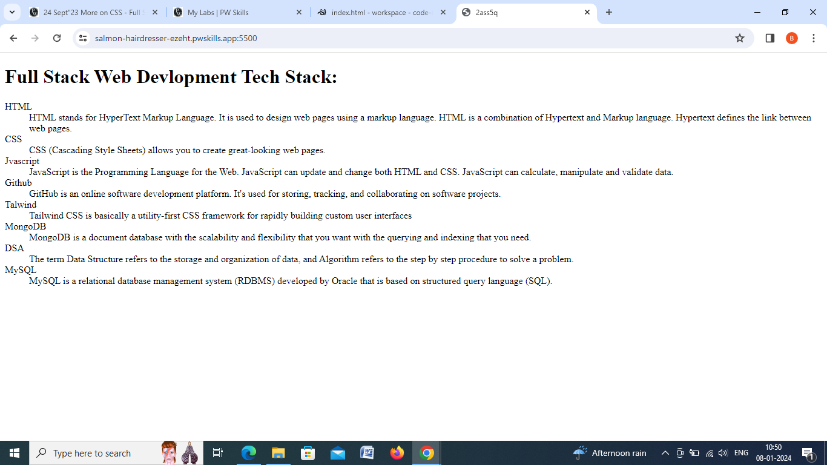

**6.)**

**Code:**

<!DOCTYPE html>

<html lang="en">

<head>

    <meta charset="UTF-8">

    <meta http-equiv="X-UA-Compatible" content="IE=edge">

    <meta name="viewport" content="width=device-width, initial-scale=1.0">

    <title>Document</title>

    <style>

        table, th, td {

          border:1px solid black;

        }

        </style>

</head>

<body>

    <ol>

        <li>HTML </li>

        <table>

<tr>

    <td>Primary use cases</td>

    <td>Ket Features/Benefits</td>

</tr>

<tr><td>Building the Structure of web pages</td>

<td><ul>

    <li>Simple and easy to learn</li>

    <li>Compitable will all web browsers</li>

    <li>Allows for semantic markup</li>

</ul></td></tr>

        </table>

        <li>CSS </li>

        <table>

            <tr><td>Primary use cases</td>

            <td>Key Features/Benefits </td></tr>

            <tr><td>Stling and layout of web pages </td>

            <td>

                <ul>

                    <li>Allow for separation of content and presentation</li>

                    <li>Enables responsive design</li>

                    <li>Offers a wide range of styling options </li>

                </ul>

            </td></tr>

        </table>

        <li>JS </li>

        <table>

            <tr>

                <td>Primary use cases</td>

                <td>Key Features/Benefits</td>

            </tr>

            <tr>

                <td>

                    <ul>

                        <li>web devlopment</li>

                        <li>web app</li>

                        <li>web servers</li>

                    </ul>

                </td>

                <td>

                    <ul>

                        <li>one of the imporant features of javascript is its eamless integration with HTML</li>

                        <li>Java script code can be embeded directly into HTML document using  script </li>

                        <li>Ability to perform Inbuild function</li>

                    </ul>

                </td>

            </tr>

        </table>

    </ol>

</body>

</html>

**Output:**

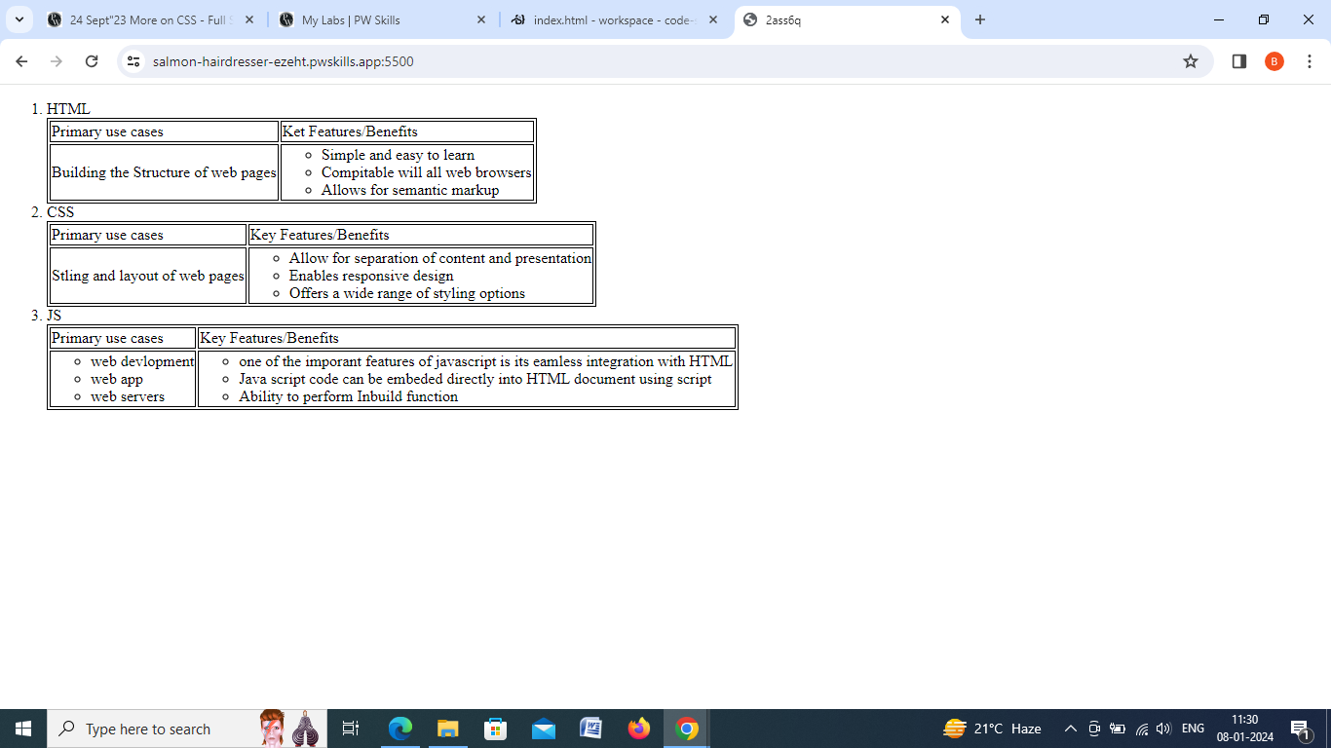

**7.)**

**Code:**

<!DOCTYPE html>

<html lang="en">

<head>

    <meta charset="UTF-8">

    <meta http-equiv="X-UA-Compatible" content="IE=edge">

    <meta name="viewport" content="width=device-width, initial-scale=1.0">

    <title>2ass7q</title>

</head>

<body>

    <ul><li><a href="#">1:INTRODUCTION</a></li>

        <ul>

    <li><a href="#">1.1 Introduction</a></li>

    <li><a href="#">1.2 Statment of problem</a></li>

    <li><a href="#">1.3 Need for the Study </a></li>

<li><a href="#">1.4 Subproblems</a></li>

<li><a href="#">1.5 Definitions</a></li>

        </ul>

    </ul>

    <ul><li><a href="#">2:RELATED LITERATURE</a></li>

        <ul>

    <li><a href="#">2.1 Theoritical paradigm</a></li>

    <li><a href="#">2.2 Conceptual Framework</a></li>

    </ul>

</ul>

<ul><li><a href="#">3: METHODS</a></li>

<ul><li><a href="#">3.1 Research Design</a></li>

<li><a href="#">3.2 Participants</a></li>

</ul>

</ul>

<ul><li><a href="#">4:RESULT</a></li>

<ul>

    <li><a href="#">4.1 Fctor analysis</a></li>

    <li><a href="#">4.2 Selection of Factor</a></li>

</ul>

</ul>

</body>

</html>

**Ouput:**

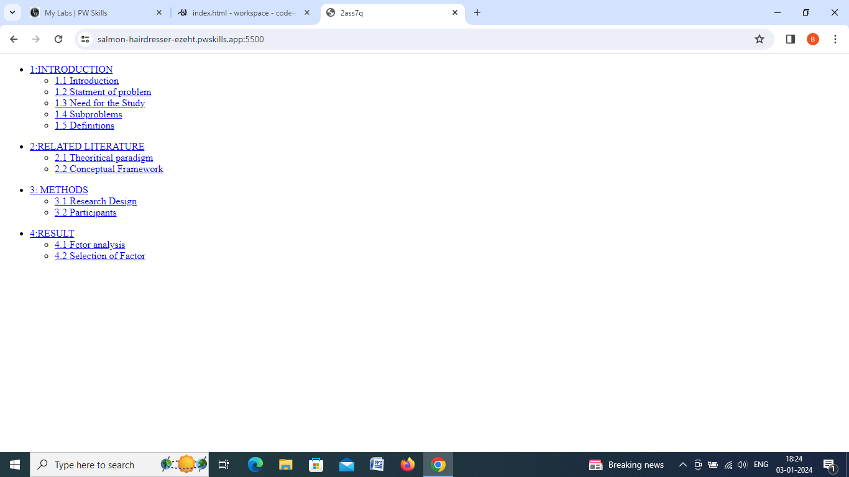

**8.)**

**Code:**

<!DOCTYPE html>

<html lang="en">

<head>

    <meta charset="UTF-8">

    <meta http-equiv="X-UA-Compatible" content="IE=edge">

    <meta name="viewport" content="width=device-width, initial-scale=1.0">

    <title>Table </title>

    <style>

        table, th, td {

  border:10px solid black;

}

        </style>

</head>

<body>

    <table>

        <tr ><td  colspan="5">Conference Schedule</td></tr>

        <tr><td>Time </td>

        <td>Room1 </td>

        <td>Room2 </td>

        <td>Room3 </td>

        <td>Room4</td></tr>

        <tr><td rowspan="3">9:00 AM-10:00 AM</td>

        <td rowspan="2">Keynote</td>

        <td>Session A </td>

        <td>Session B </td>

        <td rowspan="3">Session C </td></tr>

        <tr><td>Session D </td>

        <td>Session E </td></tr>

        <tr><td>10:30 AM-11:30 AM</td>

        <td colspan="2">Session F</td></tr>

        <tr><td>12:00 PM-1:00 PM</td>

        <td colspan="4">Lunch Break</td></tr>

        <tr><td rowspan="2">1:00 PM-2:00 PM</td>

        <td>Session G</td>

        <td rowspan="2">Session H</td>

        <td>Session I </td>

        <td>Session J</td></tr>

        <tr><td>Session K</td>

        <td>Session K</td>

        <td>Session M </td></tr>

    </table>

</body>

</html>

**Output:**

